CLASSIC MOROCCO TOUR
October 12-19, 2019
$2,289.00
(per person, double)

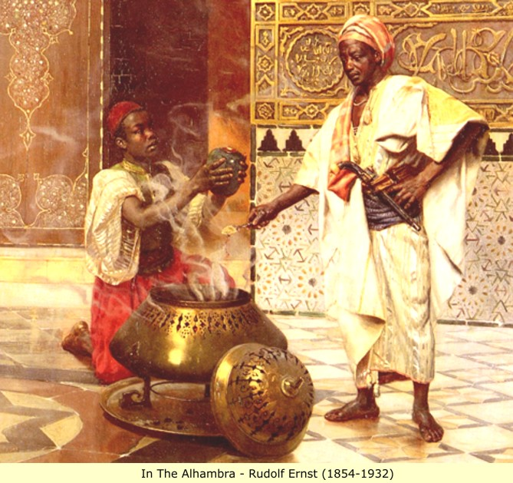

PACKAGE INCLUDES:
- Round Trip Flights Raleigh-Durham-Casablanca via Air France and Delta
- Airline taxes and fuel surcharges
- 6 nights accommodations in your choice of hotels:
  - 1 night Le Diwan Rabat, Rabat, Morocco
  - 2 nights Fes Marriott Hotel Jnan Palace, Fez, Morocco
  - 2 nights Movenpick Hotel Mansour Eddahbi Marrakesh, Morocco
  - 1 night Kenzi Tower Hotel, Casablanca, Morocco
- 11 meals, 6 Breakfasts, 2 Lunches, 3 Dinners
- Sightseeing per itinerary in modern air-conditioned motor coach
- Services of English-speaking tour escort/manager throughout
- Local guides as required
- Entrance fees per itinerary
- Porterage of one piece per person on arrival and departure at each hotel
Special Features:
- Visit the ancient Roman ruins of Volubilis, a UNESCO World Heritage Site
- Take a short bus tour of the imperial city of Fez
- Enjoy a special home hosted dinner by a local family in Fez
- Admire the 12th century Koutoubia Minaret, used as the prototype for Seville's La Giralda tower
- Marrakesh Culinary Demonstration & Majorelle Gardens with Lunch
- View Hassan II Mosque, build to commemorate the former king's 60th birthday
- Is This Trip Right for You?
- This program is active and involves walking over various surfaces. The pace is fast, as it includes visits to numerous sites. The longest day spent on the bus is between Fez and Marrakesh, which is approximately 6 hours. The earliest wake up call is 6 am. While most of the sightseeing lasts between 1 to 3 hours, the full day Fez optional tour is approximately 6 hours.
Entry Requirements:
US citizens require a passport valid for six months beyond travel dates.

Prior to Departure Penalty
179 to 101 days: $200 per person
100 to 61 days: $300 per person
60 to 31 days: 75% of land
30 days or less/ no-show: 100% of cost
Travel Insurance is strongly recommended at an additional cost of $159.00 per person.
Itinerary For: Eight Day Classic Morocco
This Eight day program is a comprehensive fast-paced tour featuring the highlights of Morocco in a brief visit.
DAY 1, Saturday - Depart for Morocco
Depart RDU at 5:42 pm on your overnight flight.
DAY 2, Sunday - Arrive in Casablanca & Travel to Rabat
Arrive at 7:45 am in Paris. Connect to a flight departing 12:45 pm arriving at 2:50 pm in Casablanca. Be met and transfer to your hotel in Rabat where you have the rest of the day at leisure to explore the capital city of Morocco or relax in your hotel for your upcoming adventure. This evening, enjoy a an orientation meeting with your Tour Manager, followed by a Welcome Dinner
Overnight: Rabat
Meals: Dinner
DAY 3, Monday - Rabat Sightseeing then Travel to Fez
This morning, enjoy a city tour of Rabat. View the Royal Palace and the ancient ruins of Chellah, the Oudaya Kasbah, and the Hassan Tower. En route to Fez, stop and visit the ancient ruins of the Roman city of Volubilis where you will get a chance to see the wonderfully preserved original mosaics, Roman Road, and city layout. As you travel through the Moroccan countryside, pass by the Holy City of Moulay Idriss for a photo opportunity. This evening, upon arrival in Fez, enjoy a short bus tour of the imperial city conducted by your Tour Manager on the way to the hotel
Overnight: Fez
Meals: Breakfast
DAY 4, Tuesday - Full Day in Fez
Enjoy a city tour of Fez. Visit the many hidden treasures of the medina that only a Moroccan guide will know. Fez served as the capital of Morocco for more than 400 years and is home to the University of Al Karaouine, the oldest operating university in the world. It is particularly famous for its tanneries and the Fes el Bali Medina. A short visit to the surrounding leather shops give you the best view of the tanneries. View the Attarine Medersa, Moulay Idriss mausoleum, and visit the Nejjarine Fountains and Museum. Opportunities for shopping for authentic Moroccan carpets. Finally, view the exterior of the Royal Palace and walk through the famed Jewish quarter of the medina where you will get a chance to walk through one of the few remaining Jewish cemeteries in Morocco. Though the city has endured periods of hardship, it has emerged more vibrant than ever, boasting its own distinctive culture, art, and even cuisine. This evening, enjoy a special dinner hosted by a local family and learn about Moroccan culture and traditions*
Home hosted dinner in Fez may be moved to another day, according to your host's availability.
Overnight: Fez
Meals: Breakfast, Lunch, Dinner
DAY 5, Wednesday - Travel to Marrakesh
This morning, depart for Marrakesh, a day-long journey taking you through the ever-changing landscape of the Moroccan valleys and Atlas Mountains along the way. Kindly note that this will be the longest coach ride of your tour. You will depart Fez in the early morning and arrive to Marrakesh in the early evening. Included will be sufficient rest stops for your comfort and a break for lunch. Your journey begins with beautiful views of the mountains around Ifrane and ends in the dry flatlands around Marrakesh, allowing you to experience the depth of the country's terrain. This evening, enjoy a short bus tour of Marrakesh, conducted by your Tour Manager en route to your hotel. Over the next day you will have ample opportunity to explore this city including the famous Djemaa el Fna Square and wide boulevards lined with restaurants and cafes
Overnight: Marrakesh
Meals: Breakfast
DAY 6, Thursday - Morning Tour of Marrakesh - Marrakesh Culinary Demonstration & Majorelle Gardens with Lunch
Morning tour of this fabulous city begins at the 16th century Saadian Tombs, where Saadian royalty found their final resting place. Continue to the Koutoubia Minaret and the beautiful Bahia Palace. You will also have the opportunity to shop for authentic Moroccan argan oil before strolling through the bustling Medina to Djemaa el Fna Square, the lively center of the city. Then enjoy a couscous cooking demo followed by lunch at a nearby restaurant. Continue to the magnificent Majorelle Botanical Gardens, inspired by French artists and fashion designer Yves St. Laurent. The rest of the day is yours for independent discoveries. Tonight, an optional horse-drawn carriage ride takes you through the night-lit streets of Marrakesh ending at a popular restaurant. A typical Moroccan dinner is served while you listen to live music and watch an elegant belly dancing performance that caps off the night.
Optional: Dinner with Horse-Drawn Carriage Ride (PM) – not included in tour, $79.00 per person
Overnight: Marrakesh
Meals: Breakfast
DAY 7, Friday - Travel to Casablanca & City Tour
After breakfast, travel to Casablanca and transfer to your hotel. Later this afternoon, tour Casablanca. Your half day sightseeing tour includes the exterior of the Hassan II Mosque**, the largest Mosque in Morocco and the beautiful Corniche seaside. Take a moment to catch your breath at the end of your Moroccan adventure to admire the serenity of the Atlantic Ocean. Continue on a short drive through the residential areas of Casablanca to the city center to visit the Mohamed V Square, the Habous quarter and the Notre Dame de Lourdes Cathedral. Tonight, say goodbye to your fellow travelers and enjoy a Farewell Dinner at a local restaurant on the Corniche
Overnight: Casablanca
Meals: Breakfast, Dinner
DAY 8, Saturday - Depart Morocco
Transfer to the airport for your flight departing 7:40 am arriving at 11:45 am in Paris. Connect to a flight departing at 1:50 pm arriving at 5:15 pm in Atlanta. Complete Immigration and then connect to a Delta flight departing 8:32 pm arriving at 10:00 pm in RDU.
Meals: Breakfast
Deposits/Payments:
A $300.00 per person deposit is required to book this tour, due by July 1, 2018. Final payment due by August 1, 2019.
Other payments: $350.00, September 1; $350.00, November 1; $350.00 February 1; $350.00, April 1; $350.00 June 1; Final August 1, 2019.
The premium for travel insurance coverage should be included along with the 1st or 2nd installment payment: $159.00 per person.
Please make all payments to: Joy! Cruises and Tours Inc, P O Box 900, Graham, NC 27253. Call 919-680-3337 for more information, or email: info@joycruisesandtoursinc.com.

