TOUR PORTUGAL!
May 14-21, 2019
$2498.00
(per person, double)

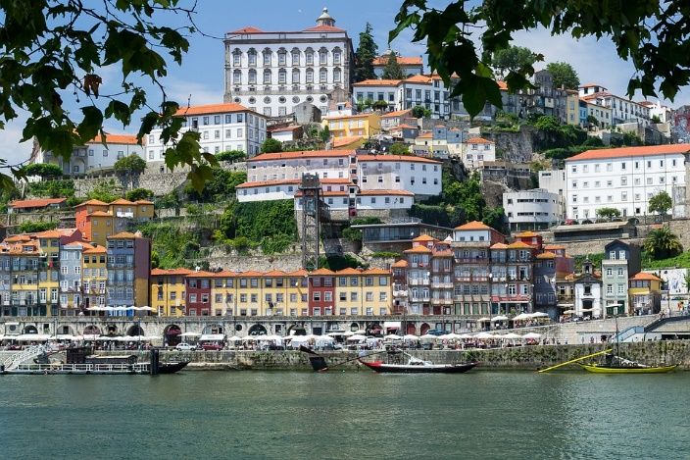

- Flights between RDU and Porto, and Lisbon and RDU via United Airlines
Airline taxes & fuel surcharges included.
- 6 nights First Class accommodations at the following or similar hotels:
  - 2 nights Porto at Crown Plaza Porto
  - 1 night Tomar at Dos Templanos
  - 3 nights Lisbon at Mundial
- Hotel taxes, fees & service charges
- Hotel porterage
- All transfers
- 12 meals: 8 breakfasts, 6 dinners with wine (including a Fado Dinner and a River Cruise)
- Sightseeing per itinerary in modern air-conditioned motor coach
- Services of English-speaking tour manager throughout
- Services of local guides per itinerary
- Entrance fees per itinerary
- Comfortable wireless earphones for enhanced touring
Special Features
- Visit the Stock Exchange, renowned for its exquisite façade and ornate gilded Arabian Hall in Porto
- Enjoy a Port Wine Tasting in Porto
- Visit Coimbra University, one of the oldest universities in Europe
- Duoro River Cruise with Dinner
- Visit the Basilica of Our Lady of the Rosary in Fatima one of the most important Catholic shrines in the world
- Tour the Convent of Christ in Tomar, a UNESCO World Heritage Site
- Stop and view the unique Ossuary Chapel in Evora
- Visit the Cathedral of Lisbon, the oldest place of worship in the city
- Tour to Sintra
- Fado Dinner
- Enter the Church and Monastery of Santa Maria, the first Gothic buildings in Portugal in Alcobaca
*Not Included:
Optional tours and gratuities.
Cancellation
Once a payment has been made, cancellations will apply per the schedule below based on the date the written cancellation is received and will only be accepted in writing.
Cancellation fees apply to packages and/or services as indicated below. Package cancellation fees include airfare, except when Instant Purchase Airfare or a group airfare is purchased. Once airfare is purchased, either at time of booking for Instant Purchase Airfare or at time of full payment for Gate 1 Airfare, airline tickets will be issued and are always subject to 100% penalty. The final group price for Custom Tours is based on the number of paying passengers which may be impacted by individual cancellations, in which case a revised group invoice will be issued up to departure date.
Prior to Departure Penalty
179 to 101 days: $200 per person
100 to 61 days: $300 per person
60 to 31 days: 75% of land
30 days or less/ no-show: 100% of cost
Travel Insurance is strongly recommended at an additional cost of $159.00 per person.
Itinerary For: 8 Day Portugal
DAY 1, Monday - Depart for Portugal
Depart RDU at 4:11 pm arriving at 6:00 pm in Newark. Connect to a flight departing 9:45 pm on your overnight flight.
DAY 2, Tuesday - Arrive in Porto
Arrive at 9:45 am in Porto. Be met and transfer to your hotel. If the rooms are not ready for check in, then you may leave your bags with the bellmen and begin to enjoy Porto on your own. The balance of the day is at leisure to explore Portugal's second largest city. In the evening, meet your Tour Manager and fellow travelers for a Welcome Drink and orientation meeting on the sensational journey that lies ahead, followed by a Welcome Dinner.
Overnight: Porto
Meals: Dinner
DAY 3, Wednesday - Porto City Tour - Duoro River Cruise with Dinner
Today, enjoy a sightseeing tour of Porto with a local guide. Take a panoramic drive to the mouth of the Douro River, and visit the Church of Sao Francisco and the Stock Exchange, renowned for its exquisite neoclassical façade and ornate gilded Arabian Hall. Finish the tour with a visit to a Port Wine Cellar for a tasting. Later enjoy the Douro River Cruise with dinner. Cruise along the colorful river valley, viewing the city from a new perspective. Pass by the numerous port wine cellars and under the magnificent bridges crossing the valley. Afterwards, a meal of local specialties in a typical restaurant with drinks is included
Overnight: Porto
Meals: Breakfast, Dinner
DAY 4, Thursday - Coimbra, Drive to Tomar, Convent of Christ
This morning, depart Porto and drive south to Coimbra, the third-largest city in Portugal. Visit the university of Coimbra, among the oldest universities in Europe, with more than 700 years of history. Continue your journey to Tomar, one of Portugal's historical jewels. Upon arrival, visit the hilltop Convent of Christ with its famous Manueline window. Tonight, dinner is at your hotel
Overnight: Tomar
Meals: Breakfast, Dinner
DAY 5, Friday - Fatima, Drive to Lisbon - Fado Dinner
This morning drive to Lisbon. Stop in Fatima, one of the most important Catholic shrines in the world dedicated to the Virgin Mary. Its Sanctuary welcomes millions of pilgrims from all over the world. Fatima's fame is due to the Apparitions of Our Lady of the Rosary that appeared to three shepherd children in 1917. Here, visit the great Basilica of Our Lady of the Rosary built in neoclassical style, flanked by colonnades linking it with the extensive convent. Continue your journey to Lisbon, one of the oldest cities in Europe, over 2,000 years old, and capital of Portugal since 1147. Tonight, attend the Fado Dinner. Travel to one of Lisbon's oldest districts and join one of the popular performances of local songs and traditional dances accompanied by a gentle guitar playing Portuguese melodies. Enjoy dinner with wine before a brief drive through the illuminated city
Overnight: Lisbon
Meals: Breakfast, Dinner
DAY 6, Saturday - Lisbon City Tour - Half-Day Sintra Tour
Today's tour of Lisbon highlights the variety of heritage and styles that make it one of Europe's most beautiful cities. You begin with a view of the treasured 16th century Belem Tower, a monument to Portugal's Age of Discovery. Afterward, visit the Cathedral of Lisbon and enjoy the elegant Liberdade Avenue. Take a walk along the winding cobblestone streets to Alfama, the old Fisherman's Quarter, nestled between the Grand Castle and the River Tagus. This afternoon tour to quaint Sintra, the “Glorious Eden” of Lord Byron, and ancient summer retreat of the royal court, highlighted by lavish romantic castles and stunning monuments. Visit the Sintra Royal Palace, a 15th-century royal residence, containing one of the largest tile collections in Portugal. Then enjoy some free time in the Village Historical Center before returning to Lisbon
Overnight: Lisbon
Meals: Breakfast
DAY 7, Sunday - Excursion to Evora
This morning, head to Evora. Take a guided tour and discover the town's massive walls and Roman Temple, early Gothic Cathedral, and Sao Francisco Church that is famous for its Ossuary chapel, whose walls are decorated with thousands of human bones and skulls. Head on to see Evora's main square, the Praça do Giraldo, and the cobbled streets of this former Royal town. Later, return to Lisbon. Tonight, enjoy a delectable farewell dinner with your fellow travelers
Overnight: Lisbon
Meals: Breakfast, Dinner
DAY 8, Monday - Depart Portugal
Transfer to the airport for your flight departing 10:25 am arriving in Newark at 1:35 pm. Complete Immigration and connect to a flight departing 5:25p arriving at 7:15 pm in RDU.
Meals: Breakfast
Deposits/Payments:
A $300.00 per person deposit is required to book this tour, due by June 15, 2018. Final payment due by March 15, 2019.
Other payments: $250.00, August 15; $250.00,September 15; $250.00 October 15; $250.00, November 15; $250.00 January 15; $250.00, February 15; Final March 15, 2019.
The premium for travel insurance coverage should be included along with the 1st or 2nd installment payment: $159.00 per person.
Please make all payments to: Joy! Cruises and Tours Inc, P O Box 900, Graham, NC 27253. Call 919-680-3337 for more information, or email: info@joycruisesandtoursinc.com.

